**Rajmachi Trek, Maharashtra**

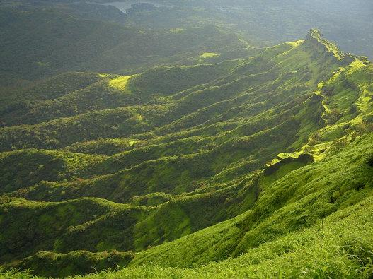

***Rajmachi Fort*** is one of the many historical forts in the rugged hills of ***Sahyadri Mountains*** in ***Maharashtra***. It consists of two twin fortresses ***Shriwardhan Ballekilla*** and ***Manaranjan Balekilla***, with a wide machi surrounding the two Balekillas. The Rajmachi fort, with the continuous efforts of the ***Maharashtra Tourism Board***, is developing quickly as a tourist spot. The beauty of this trekking destination is not just its panoramic view of lush rolling hills. It also presents two options for the trek, both of which can be completed within a day. There is a plain 15-kilometer walk from ***Lonavala*** or a rugged 2,000-foot climb from ***Kondivade*** village where one can also view the ***Kondana caves***. The best time to visit is between ***June*** and ***September***.